QUESTIONNAIRE ANALYSIS
STUDENTS WITH AND WITHOUT APECIAL NEEDS COMPARED

In our data we had answers also from special needs students. The amount of them is approximately 10 % of the total sample. We have special needs students in Finland and in Greece.
The students with special needs were quite young, as were the students without special needs. But still, especially in Finland the students with special needs may also be older – they may for example be students, who have had problems with their mental illness and who are attending vocational school later in adult age.
In Finland we considered it unappropriate to ask a lot of questions about students’ backgrounds and families, so it is not very informative to write about those. But, speaking about the questions, we found these interesting results, when we were comparing students with and without special needs.
- Who helped you to choose this school or training?
It was mother who helped the students to choose their training more often when it was speak about student with special needs.
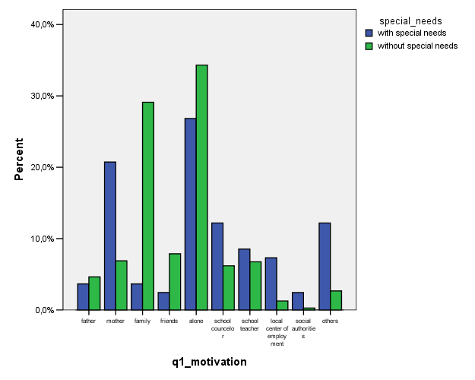

- How do you assess or evaluate the activities of the guidance counselor ?
The students with special needs said more often that the guidance was unuseful or not useful at all. Normal students felt more often that the guidance was useful for them, or they could benefit from it better. It is also true, that it´s more easy to guide a student who has a lot of opportunities in his life; special students do not. And, we should think about the way we guide special need students: do we use the tools that they experience as useful, do we use language that they understand, for example.
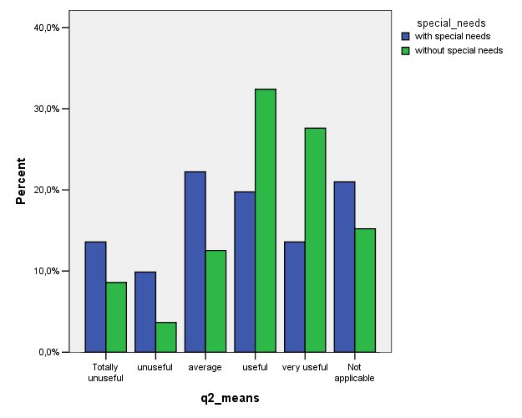

- Do you think that your present training is better for boys/girls/both?
There were no differences between special needs students and students without special needs.
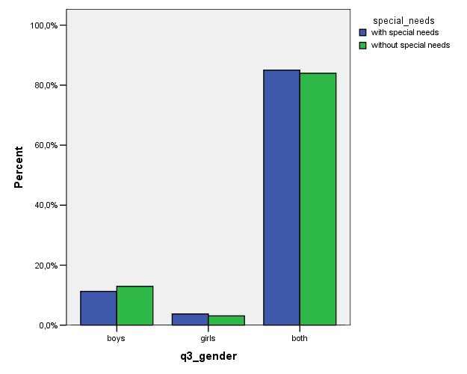

- Did you receive enough information for your choice?
In this question there were not differences between other students and special need students.
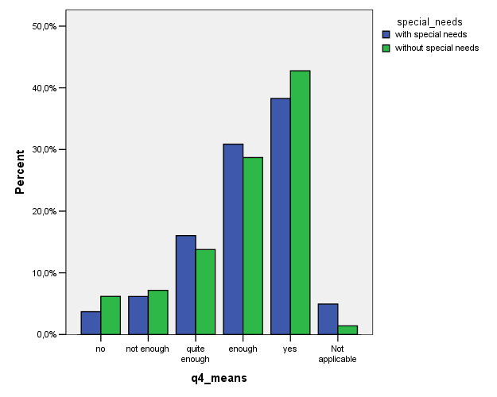

- Do you take part in the decision making of your school?
In this question there was a little difference between these two groups: students with special needs assessed more often that they had a possibility to take part in decision making of the school. In Finland we are happy to notice this result, because this is an issue that we have been developing. It would be interesting to hear in Greece, how do the students of that school take part in decision making.
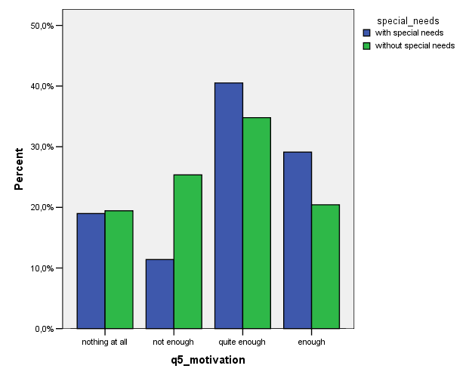
- Are you going to change your qualifications?
In this question there were not noticeable differences between other students and special need students. A majority of the all students were not going to change their qualifications.
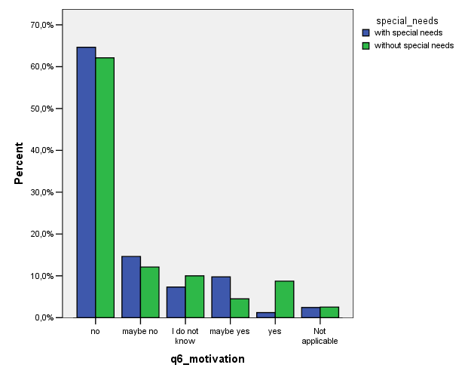

- Do you think that your family drives you to particular occupations, jobs because you are a girl or a boy?
The majority of all the students anwered no, and there were not any differences between these two groups.
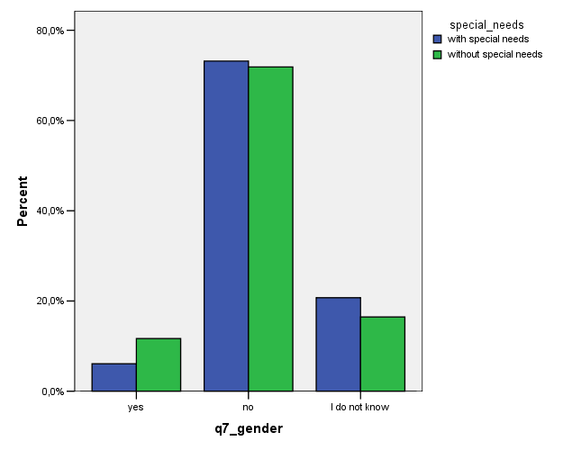

- Do you think you will have the chance to find a job related with your qualification?
In this question there were not noticeable differences between other students and special need students.
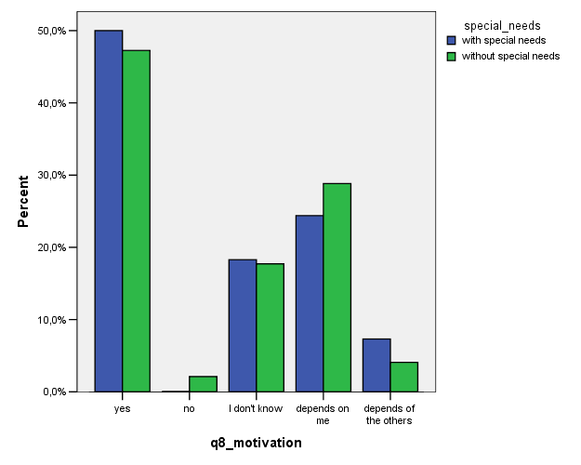

- You have chosen your career because it is mostly done by boys/girls/both/I don´t know.
In this question the majority of the students with special needs answered “I don´t know”, but we guess that is because in Finland we translated this option as “it didn´t matter”. So the sex was not an important issue when they chose their career.
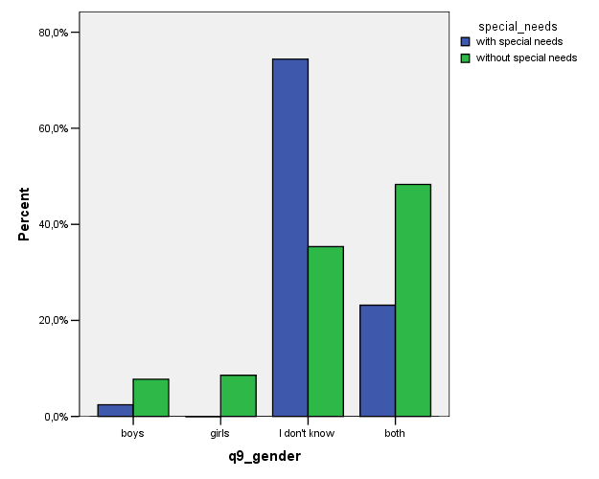

- Have your needs been noticed by the teacher in daily work?
The majority of students with special needs assessed that yes, their needs had been noticed. Other students said a little more often that their needs had not been noticed at all or had not been noticed very much.
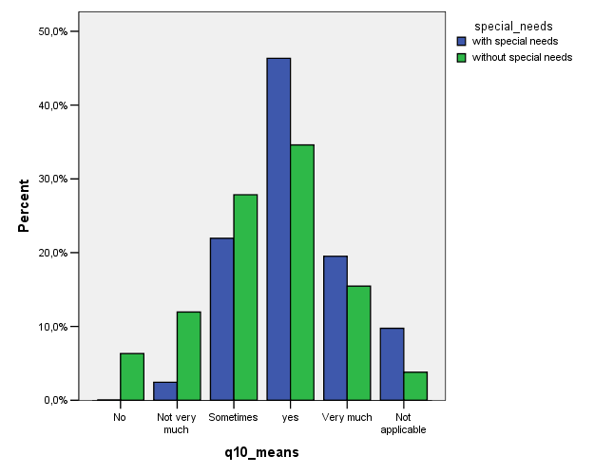
- Why did you choose your training?
Students without special needs said more often simply “I liked it” than students with special needs, when we asked the reasons why did they choose their training. Students with special needs, they do not have that kind freedom of choise, but they have to make a choise that is “best choise for me” (more often than other students).
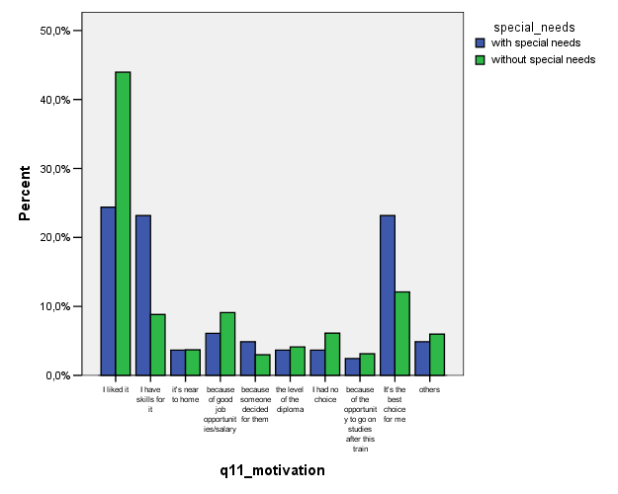
- What level of difficulties do you or did you meet?
Looking at the graphs, it seems that the students with special needs feel that they have had less difficulties than other students. Is the support and the services for these students so well organised, that they can manage without an experience of difficulties?
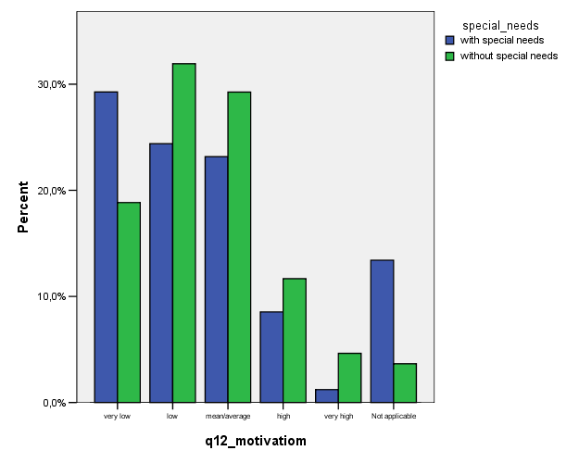
- Have you got enough guidance for living good and independent life?
There was not noticeable differences between the two groups in this question. The students with special needs were a little more positive and felt that they had had enough guidance for good and independent life.
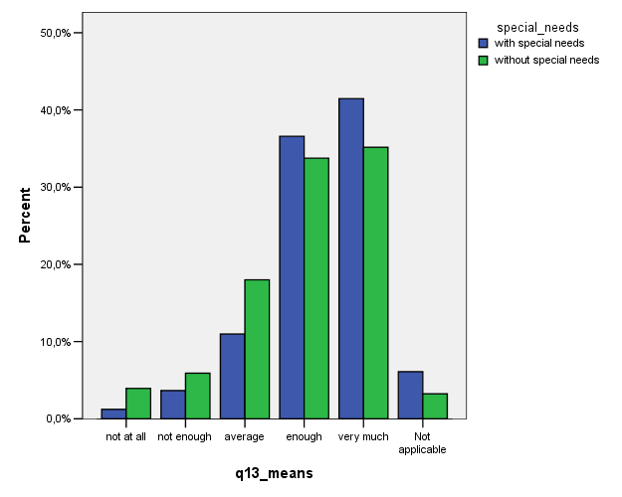
- Do you think that you have difficulties in guidance because you are a boy or a girl?
There were not noticeable differences between these two groups.
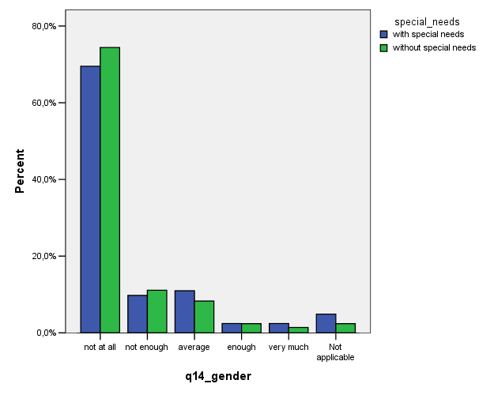
- Have you got enough guidance for insertion on the labor market?
The students with special needs assessed more that they had had enough guidance for labour market than other students.
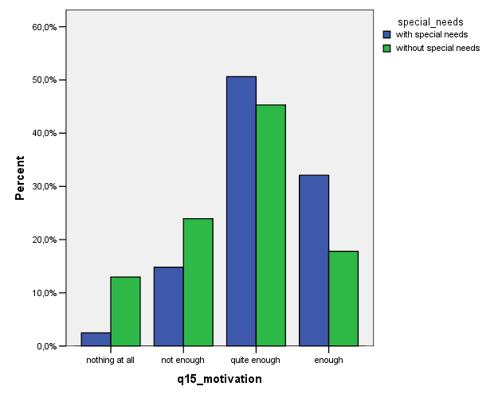
- Do you think that guidance helps you to know better yourself?
There was not noticeable differences between the two groups in this question.
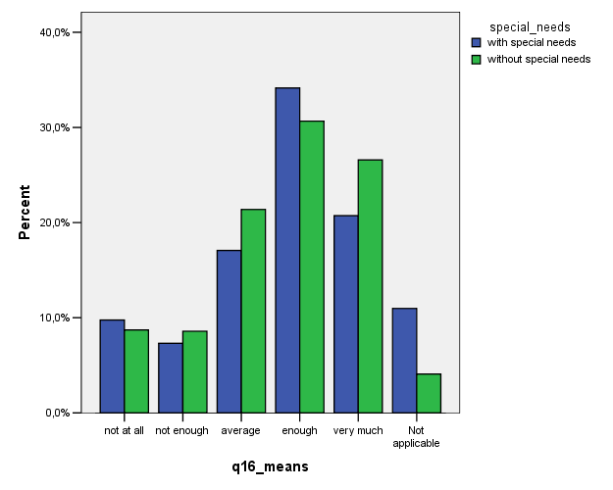
- How did you get the information about training you are following?
There were some differences between special need students and others – e.g. other students had more often got information from their class teachers . But there is no clear explanation for these differences.
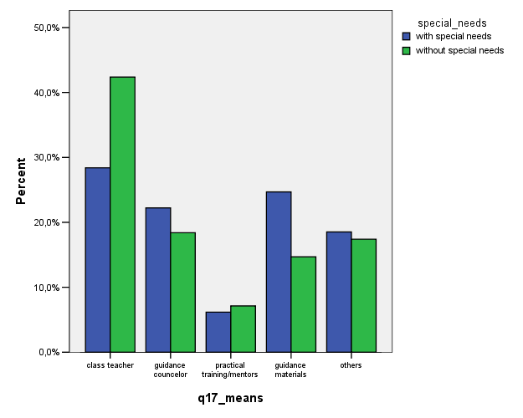
- Do you think that there are some qualifications especially for boys and especially for girls?
There were not significant differences between these two groups. But, students with special needs answered more often ”I don´t know”. Maybe they didn´t understand the question.
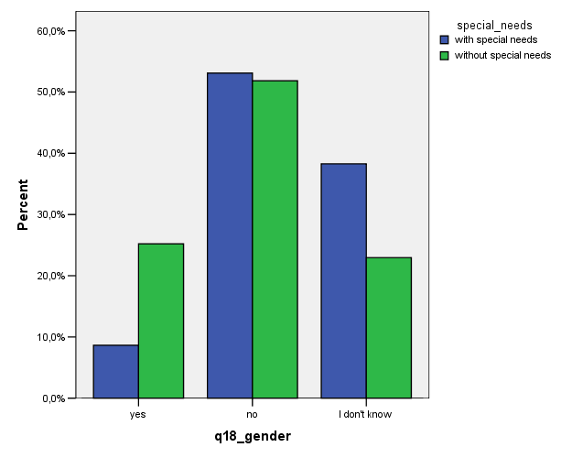

- Do you think that you are influenced in your choices by guidance?
Many of the special needs students stated that this question is not applicable. The may not have understood it. Many other students said that guidance does not influence them at all, maybe they have not had need for it.
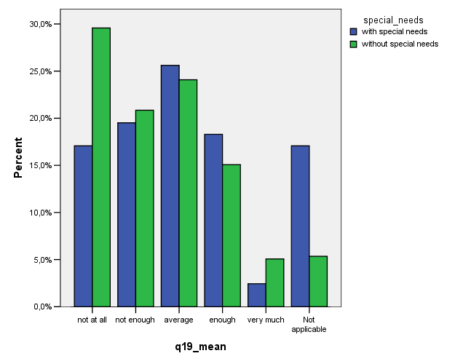
- Which was the most important factor for choosing your professional training?
The majority of all students said that it is their own abilities and skills that influence most. In that part there was even more special need students. Apparently they have had a lot of work thinking and deciding which is the realistically good choise for them.
